R語言筆記

Combine Vector to Matrix

# Box office Star Wars (in millions!)

new_hope <- c(460.998, 314.4)

empire_strikes <- c(290.475, 247.900)

return_jedi <- c(309.306, 165.8)

# Create box_office

box_office <- c(new_hope, empire_strikes, return_jedi)

# Construct star_wars_matrix

star_wars_matrix <- matrix(box_office, nrow = 3, byrow = TRUE)

star_wars_matrix

Naming a matrix

# Box office Star Wars (in millions!)

new_hope <- c(460.998, 314.4)

empire_strikes <- c(290.475, 247.900)

return_jedi <- c(309.306, 165.8)

# Construct matrix

star_wars_matrix <- matrix(c(new_hope, empire_strikes, return_jedi), nrow = 3, byrow =

TRUE)

# Vectors region and titles, used for naming

region <- c("US", "non-US")

titles <- c("A New Hope", "The Empire Strikes Back", "Return of the Jedi")

# Name the columns with region

colnames(star_wars_matrix) <- region

# Name the rows with titles

rownames(star_wars_matrix) <- titles

# Print out star_wars_matrix

star_wars_matrix

Matrix calculation

# Construct star_wars_matrix

box_office <- c(460.998, 314.4, 290.475, 247.900, 309.306, 165.8)

star_wars_matrix <- matrix(box_office, nrow = 3, byrow = TRUE,

dimnames = list(

c("A New Hope", "The Empire Strikes Back", "Return of the Jedi"),

c("US", "non-US")

)

)

# Calculate worldwide box office figures

worldwide_vector <- rowSums(star_wars_matrix)

worldwide_vector

Adding a column ➔Matrix

# Construct star_wars_matrix

box_office <- c(460.998, 314.4, 290.475, 247.900, 309.306, 165.8)

star_wars_matrix <- matrix(box_office, nrow = 3, byrow = TRUE,

dimnames = list(c("A New Hope", "The Empire Strikes Back", "Return of the Jedi"), c("US", "non-US")))

star_wars_matrix

# The worldwide box office figures

worldwide_vector <- rowSums(star_wars_matrix)

worldwide_vector

# Bind the new variable worldwide_vector as a column to star_wars_matrix

all_wars_matrix <- cbind(star_wars_matrix, worldwide_vector)

all_wars_matrix

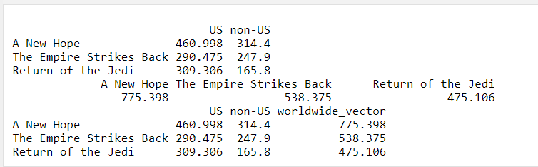

Adding a row ➔Matrix

#

star_wars_matrix

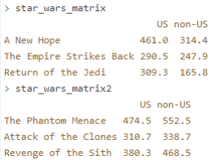

star_wars_matrix2

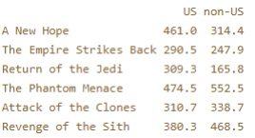

# Combine both Star Wars trilogies in one matrix

all_wars_matrix <- rbind(star_wars_matrix, star_wars_matrix2)

all_wars_matrix

Selection of matrix elements

all_wars_matrix[1,2] selects the element at the first row and second

column.

all_wars_matrix[1:3,1:2] results in a matrix with the data on the rows 1,

2, 3 and columns 1, 2.

